Pyshark and Scapy Lab

You will scraping and manipulating packets with pyshark and scapy. Please make sure that these two libraries are installed as well as Python 3.x

Using pyshark.

* Download cap.pcap from Blackboard
* Using pyshark, write a function in python that takes in a string file path to read the file pcap file. Save your file as pyshark .pcap. Pretty print your results and post a screenshot of the output.

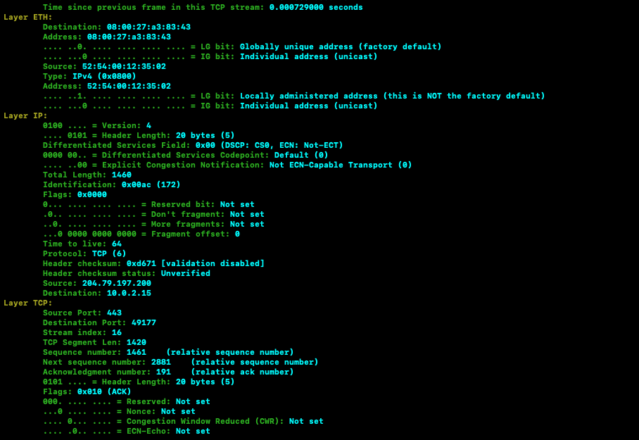

* Modify your output to keep track of tcp streams. (Hint: tcp streams are in pkt.tcp.stream)

1. How many packets are in the 2nd stream (pkt.tcp.stream =2) ? 2
2. What’s the largest tcp stream number? 9

Using Scapy

* Create a new script called scapy.py
* Read the pcap file using scapy. Pretty print the output and paste a screenshot of the results.

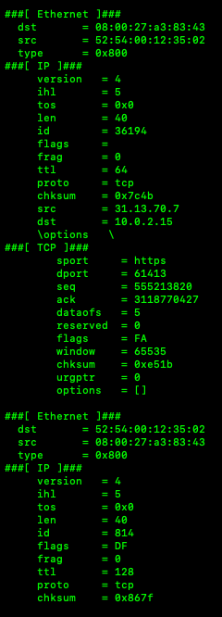

* Hexdump the entire packet list and screenshot

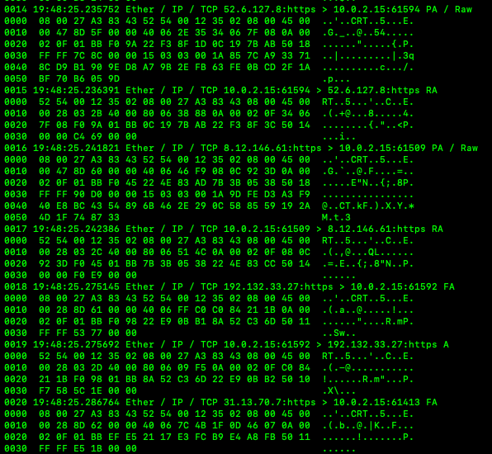

* Save the fifth packet as a pdf report and attach it. Name it five.pdf. You will need the PyX library
* Traceroute to ‘8.8.8.8’

How many hops were there? Will vary